Logic Design

EECS101001

Lab 2: Applications of Multiplexer – Report

104021215 熊 磊

1. Foreword

This Lab is trying to use Multiplexer (or Selector) to select the mudule by  **Sel**  with input  **A** , **B** , and output is  **Out** , **Ovf** .

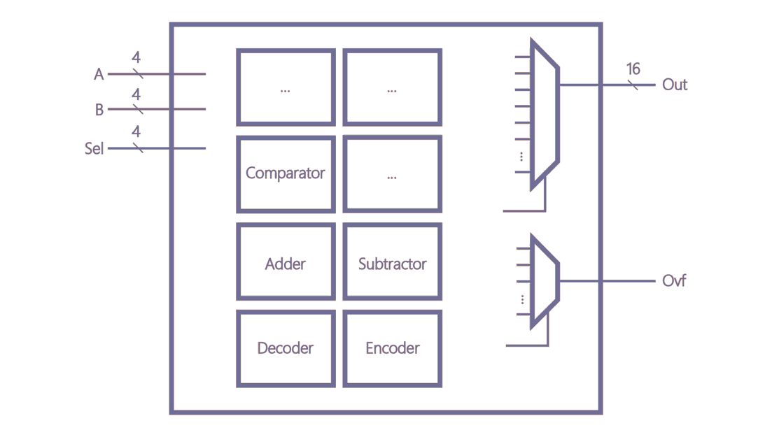

1. Implementation Details and Designs

* Multiplexer

I use **always block** to implement the Multiplexer. The code is too long to show here, one can check **AM.v** in line #25~#109. Below is the image created by Design Vision.

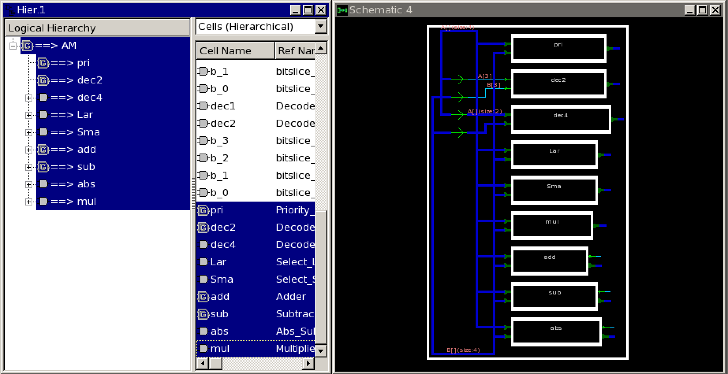

Hence, we need to implement each module for each module.

* [0000]Priority Encoder

First I easily combine the two inputs **a**, **b** to **wire[7:0]ab**.

Then one can get the result of priority encoder by assign method check the bit form MSB to LSB one by one.

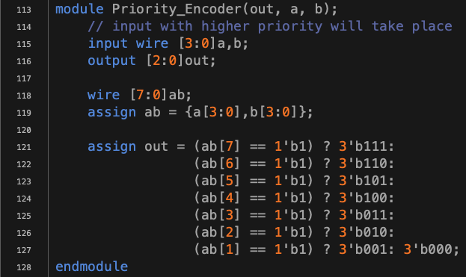

* [0001]~[0111]A&B, A^B, A*B, A>>>1’b1, …, A<<1’b1

For these functions, without restrictions, I directly use Verilog built-in operation.



* [1000] 2-to-4 decoder

We need to use **only gate level** to implement 2-to-4 decoder, we first write down the truth table and draw a simple diagram below.

|  |  |  |  |  |  |
| --- | --- | --- | --- | --- | --- |
| A0 | A1 | D0 | D1 | D2 | D3 |
| 0 | 0 | 0 | 0 | 0 | 1 |
| 0 | 1 | 0 | 0 | 1 | 0 |
| 1 | 0 | 0 | 1 | 0 | 0 |
| 1 | 1 | 1 | 0 | 0 | 0 |

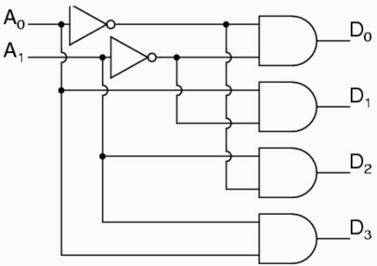

Therefore, we need four **and gate** and two **not gate**. The code is below.



* [1001] 4-to-16 decoder

By reusing 2-to-4 decoder, the idea is very simple, we can draw a diagram below.

|  |  |  |
| --- | --- | --- |
| A[3:2] | B[3:2] | Out |
| 00 | 00 | 0000_0000_0000_0001 |
| 00 | 01 | 0000_0000_0000_0010 |
| 00 | 10 | 0000_0000_0000_0100 |
| 00 | 11 | 0000_0000_0000_1000 |
| 01 | 00 | 0000_0000_0001_0000 |
| 01 | 01 | 0000_0000_0010_0000 |
| 01 | 10 | 0000_0000_0100_0000 |
| 01 | 11 | 0000_0000_1000_0000 |
| 10 | 00 | 0000_0001_0000_0000 |
| 10 | 01 | 0000_0010_0000_0000 |
| 10 | 10 | 0000_0100_0000_0000 |
| 10 | 11 | 0000_1000_0000_0000 |
| 11 | 00 | 0001_0000_0000_0000 |
| 11 | 01 | 0010_0000_0000_0000 |
| 11 | 10 | 0100_0000_0000_0000 |
| 11 | 11 | 1000_0000_0000_0000 |

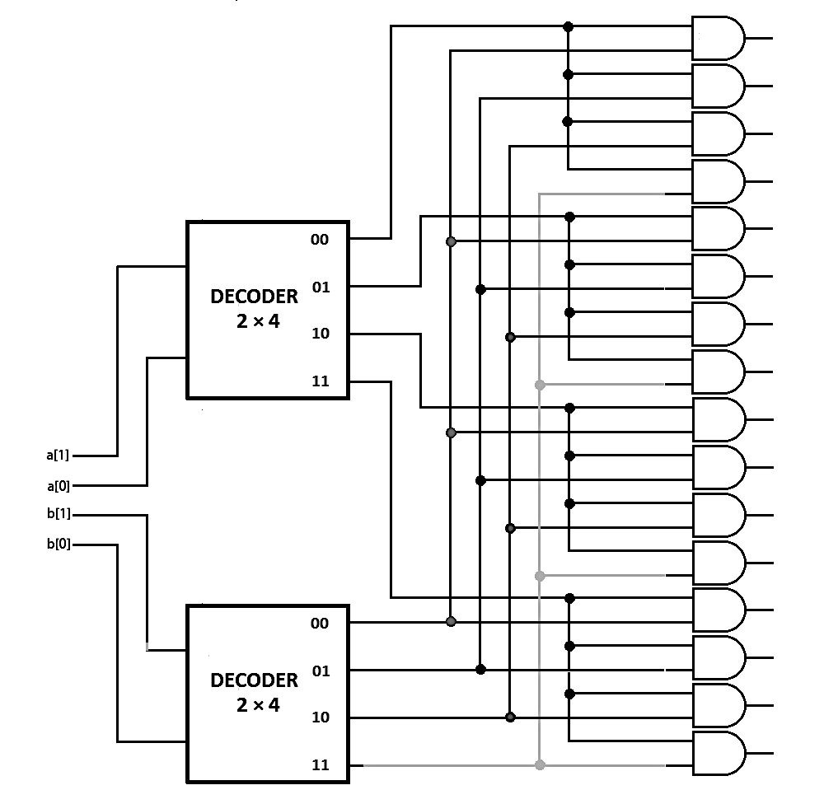

Therefore, we need sixteen **and gate** and two **2-4 Decoder**. The code is below.



* [1010]~[1011]Select the larger number, Select the smaller number

[Design Bit Slice - Comparator]

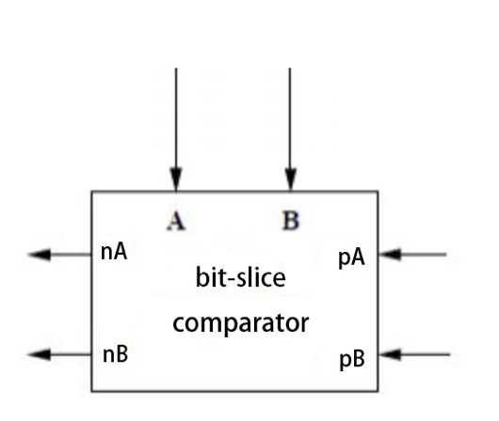 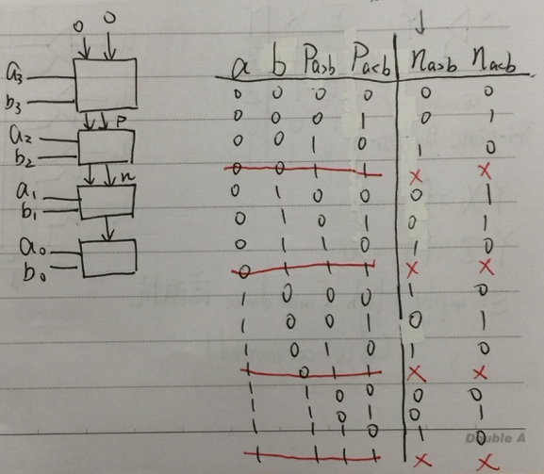

nA is equivalent to (A+pA)&pB’ nB is equivalent to (B+pB)&pA’

If nA is 1, A>B; if nB is 1, B>A.



So, we can use Comparator repeatedly, like this. For example, **Select the larger number**, We just have to check if **nA** is 1.

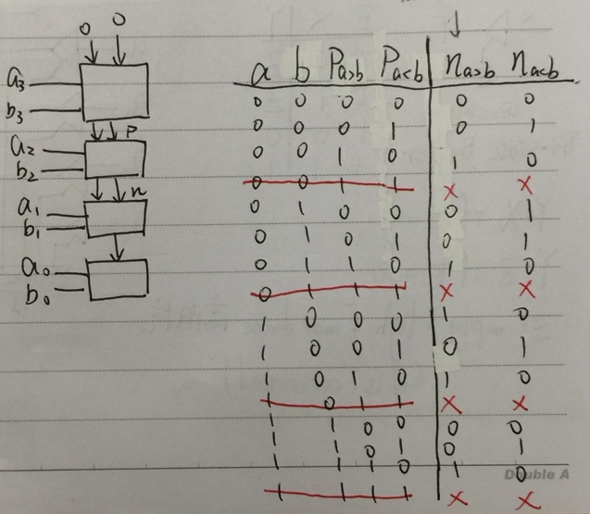 

On the other hand, **Select the smaller number**, we can just choose the one not the large.



* [1100]A+B

[Design Bit Slice – Full Adder]

Here we first analyze **cout**and **s**. By drawing a truth table and K-map, found that they are Majority function and ODD function respectively.

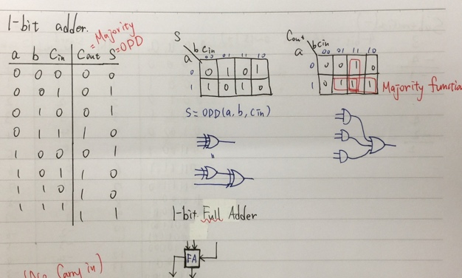



Now, we can use Full adder repeatedly for four-digits input to implement **Adder**. To detect overflow, using an **xor** gate at the last Full Adder.

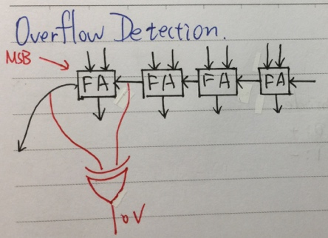 

* [1101]A-B

[Reuse Adder]

It’s easy to implement Subtractor by reusing Adder. We just change the problem **A-B** to the problem **A+(-B)**. Just like line #227 below.



* [1110]|A-B|

[Reuse Subtractor]

If overflow, we don’t care about the output.

The only step we need to care is to make sure the output is positive. Therefore, convert to positive if it’s negative. As show in Line #239.



* [1111]A*B

[Only Gate Level]

I use array Multiplier to implement. The diagram is below. It’s hard to say in text, but the main idea is to reuse Full Adder(made by gate level) to control bit slice, and use and gate to do bit-multiplying.

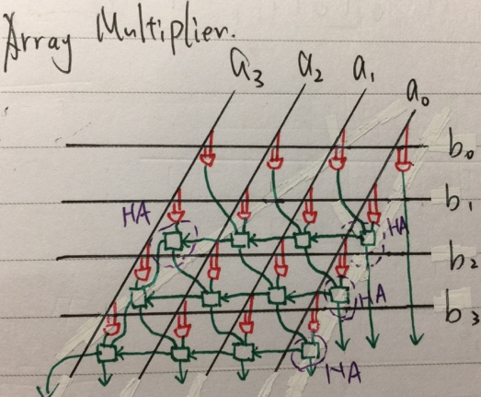 

1. Simulation Result

**[Before Synthesis]** **[Run Synthesis]**

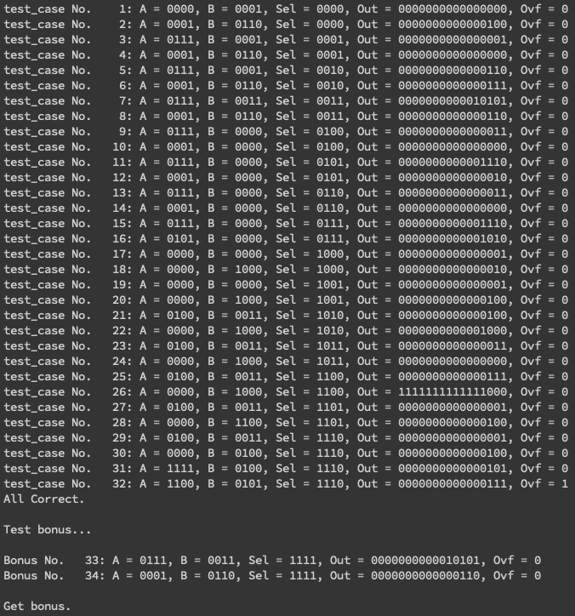 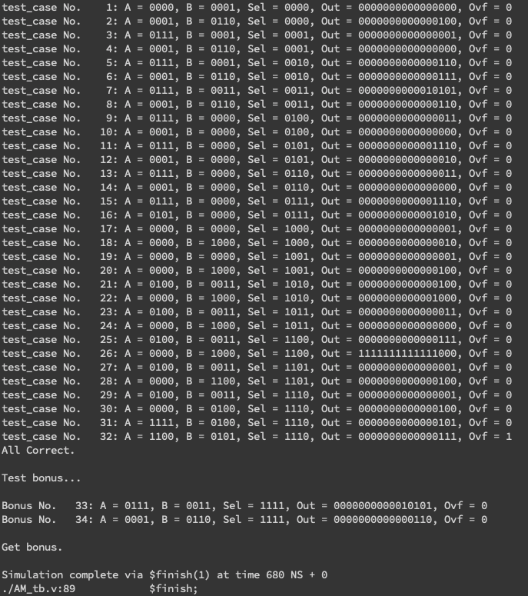

1. Report Area



1. Encountered Problems and Solving

* Cannot using **assign** in **always block**.
* Cannot instantiate **module** in **always block**.
* Reg can only using in **always block**.
* We can use big parentheses {} to do sign extension or merge.

e.g. {a, b}, {12'b0, a&b}, {8'b0, {{4{a[3]}}, a}*{{4{b[3]}},b}}…

Amazing!!

* To reduce the coding time, drawing the diagram is really helpful!

1. Questions

* Why we can ignore the function name to built-in module but cannot ignore in my own module?

e.g.

and (and0,a,b); legal!

my_and (and0,a,b); **illegal!**

my_and and_0(and0,a,b); legal!

* What is meaning of **combinational “area”** in report_area.txt?

1. Impression and Experience

Before I start this lab, I think this is a really tough, cause I have to implement totally 16 function. However, most of them are easily. By reusing the module, can reduce workload significantly!! I think, however, the most difficult one is bonus one, since there are lots of gate have to be connected…

Thank TAs for helping us and teaching us. Take care:-)